1. Go to this folder: **R:\storage\libarchive\b\1. Processing\8. Other Projects\Scholars-Mine-GitHub\Stand Alone Author Split**
2. Click on the path and type **“cmd”** and press **enter**.

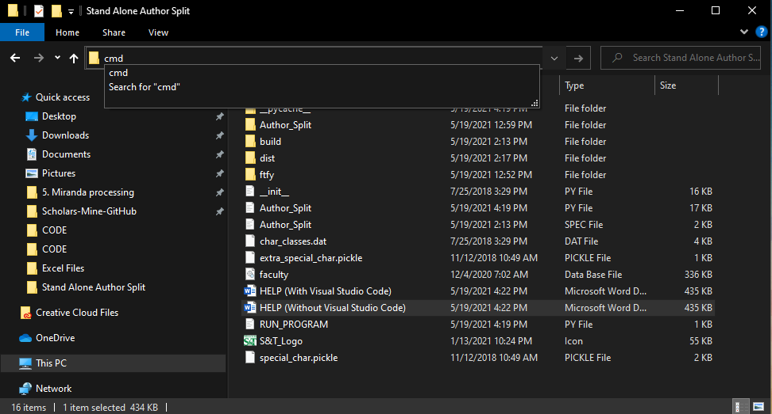

1. The command window should open and look like this…

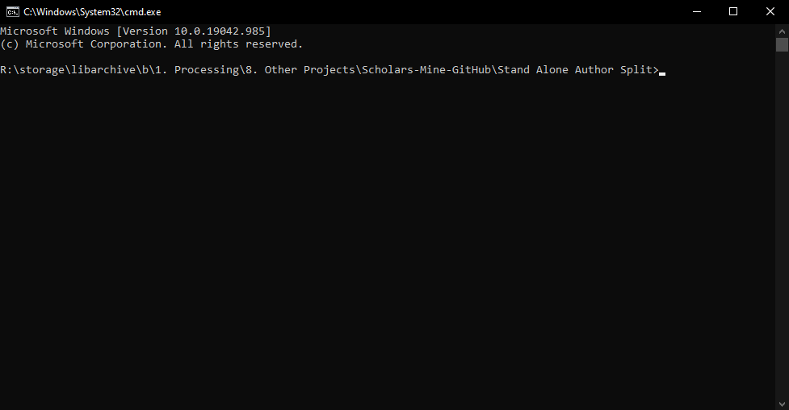

1. Type **“python run.py”** in the command window and press **enter**.

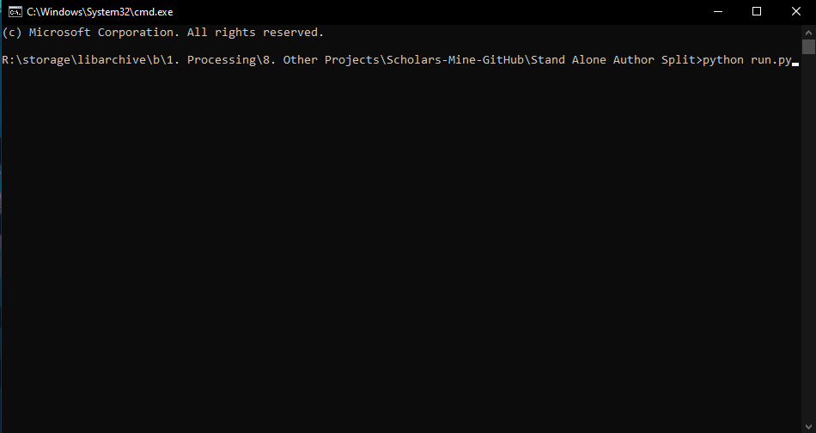

1. The program should launch and look like the following…

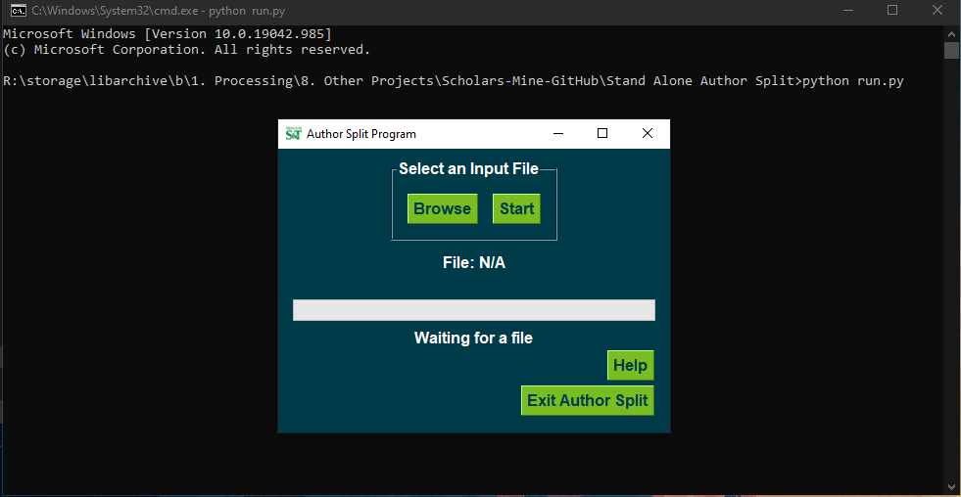

1. Click on browse to find a file.
2. Select a file that has **“_ReadyForAuthorSplit”** at the end and click open (bottom right hand corner).
   1. If your file does not have this, run it through the **“Harvest & Reformat”** program in the **“Control Panel Program”** that can be found here: **R:\storage\libarchive\b\1. Processing\8. Other Projects\Excel Files**

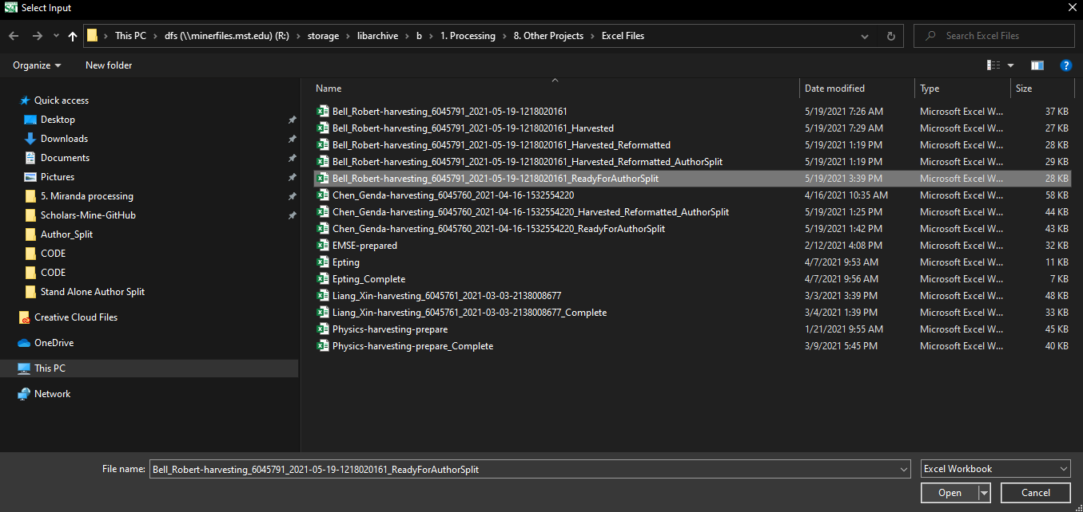

1. Press Start

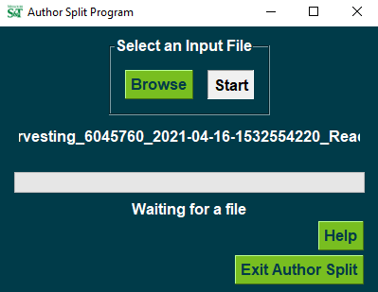

1. If it says **“Excel Created”** below the progress bar, then the program is finished.

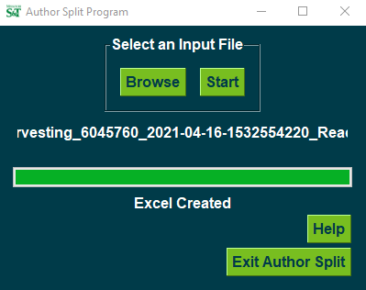

1. You can now click “Exit Author Split” or close the window with the “X” in the upper right-hand corner of the window OR select browse again to run another file.

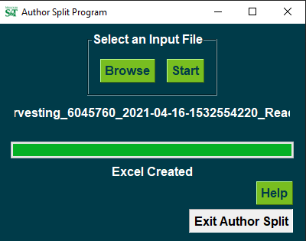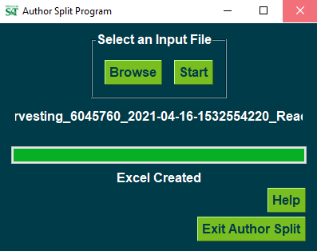

1. You can close out of the command window with the “X” in the upper right-hand corner.

